

BONOLO TRUCKING COMPANY (BTC)

MANAGEMENT SYSTEM

INDEX

1. Registration........................................................................................................

1.1 Login...............................................................................................................

2. Setting Details.......................................................................................

2.1 Edit Profile........................................................................................

3. Company’s trucks…………………………………………………………………………

4. Manage Employees....................................................................................

4.1 Add Driver...................................................................................................

4.2 View Driver’s information…………………………………………………………………………

5. Manage Fleet............................................................................................

5.1 Add Truck.......................................................................................................

5.2 View truck Information....................................................................................

7. Route Information..................................................................................

8. Logging out......................................................................................

**REGISTRATION**

* First install the system onto your phone or computer depending on the device you using.
* For a first time user click the Register button if not enter credentials and click the log in Button.
* Then the registration button will navigate you to the next window which is the Registration phase where you have to enter all you details.

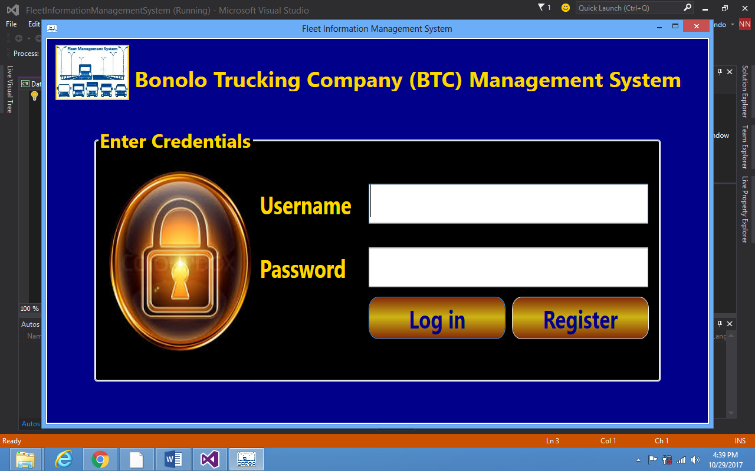

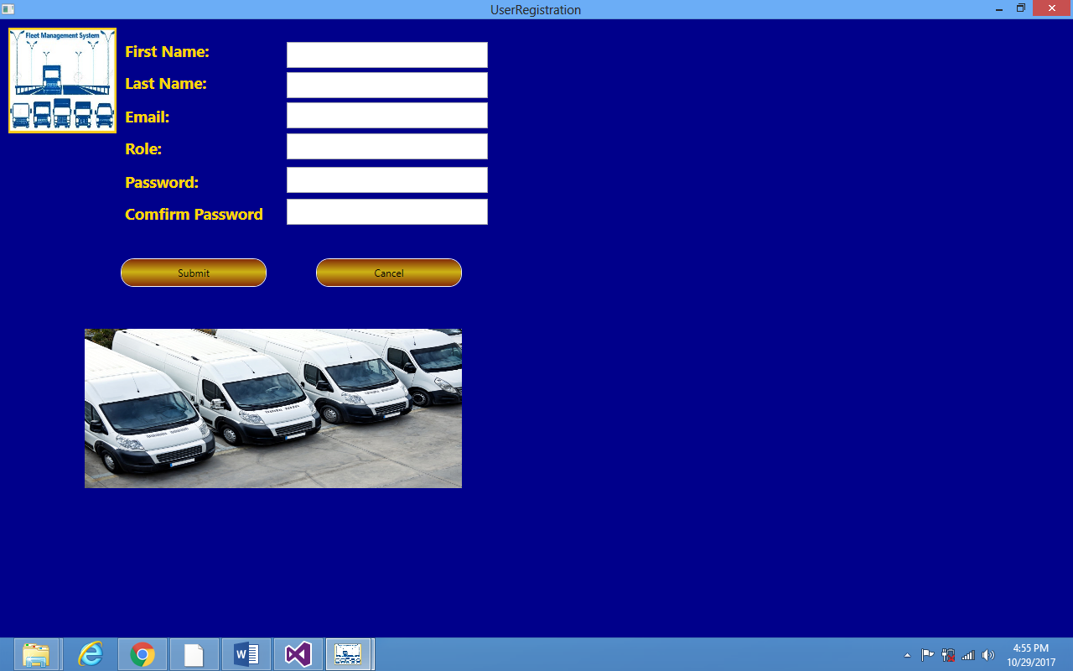

* After all details are entered click Button Submit

**LOGIN**

* After the user is registered then the first time user will be able to log in

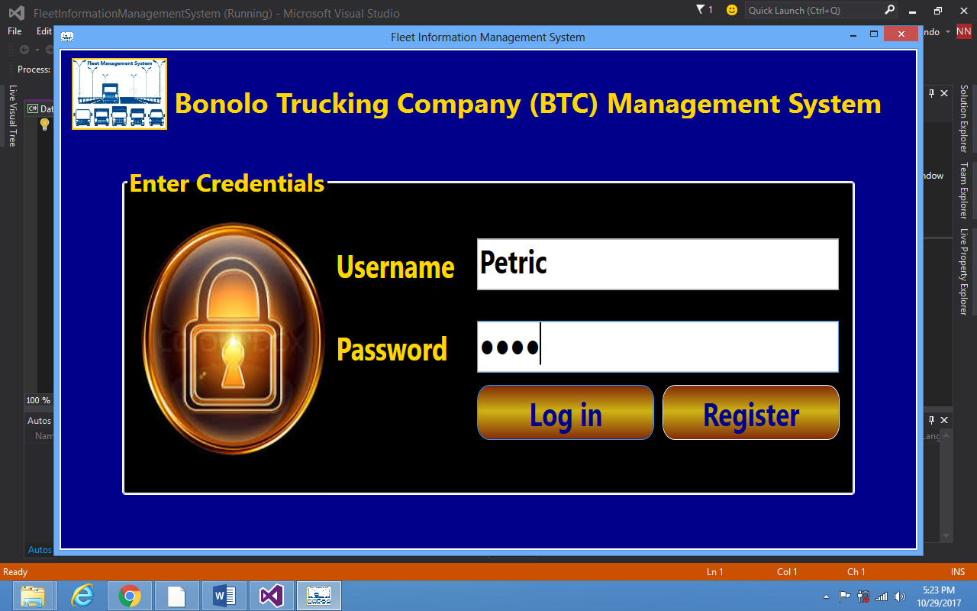

* After you have clicked button Log in, the button will navigate you to the next window where u have to put in details of the customer.

SETTING DETAILS AND EDITING DETAILS OF A CUSTOMER

* On this window u are able to enter details of a customer and edit the information, after you finish you can click the button submit.
* Then the information entered will be added to the database.

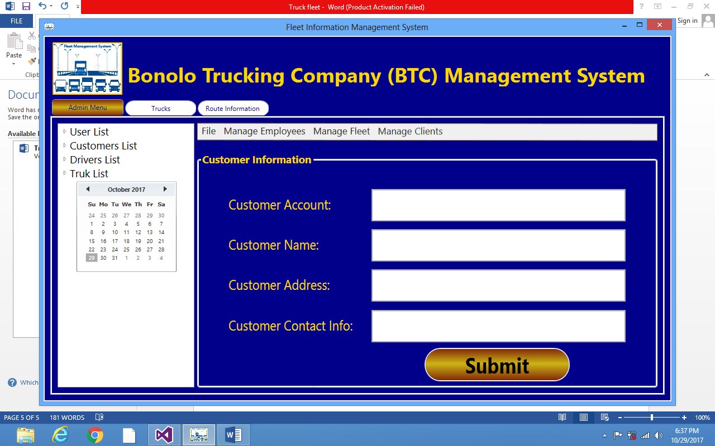

**Company’s trucks**

* There is a tab highlighted with a slim arrow when u click that tab u will see the types of trucks available.
* This is the window where u get to see the types of vehicle the company has.

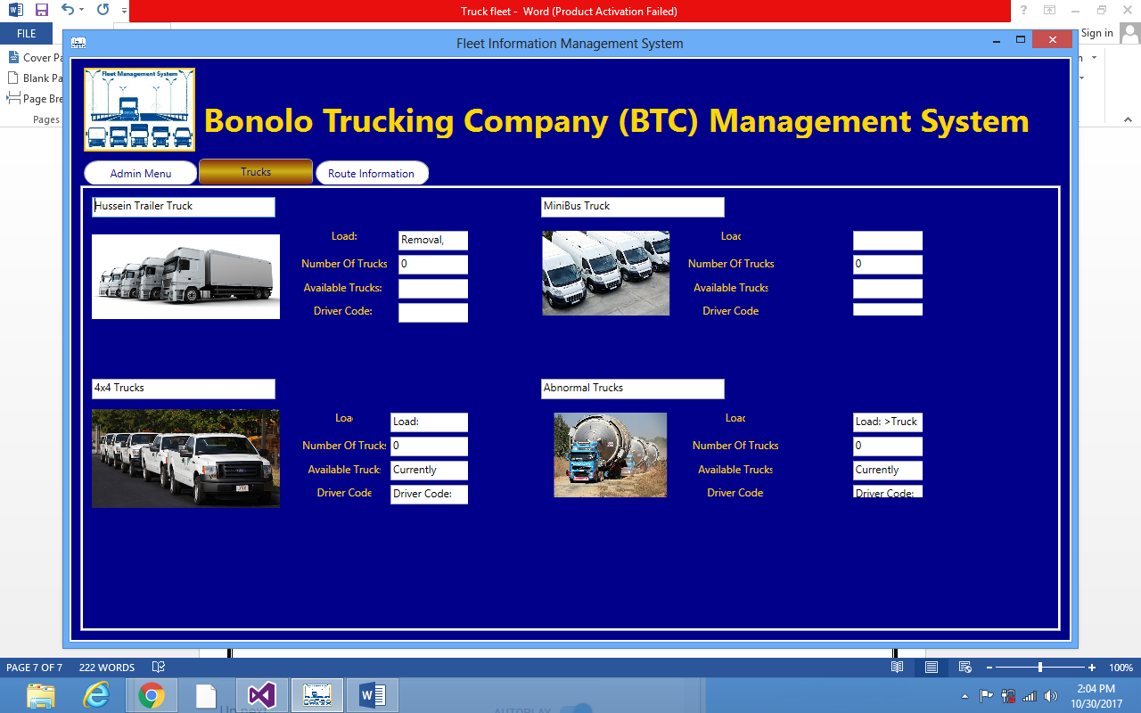

**Manage Employees**

* In the very same window there is a tab written Manage Employees
* When the manage employee tab is clicked u will be able to see two other tabs written Add new Driver and View Driver information

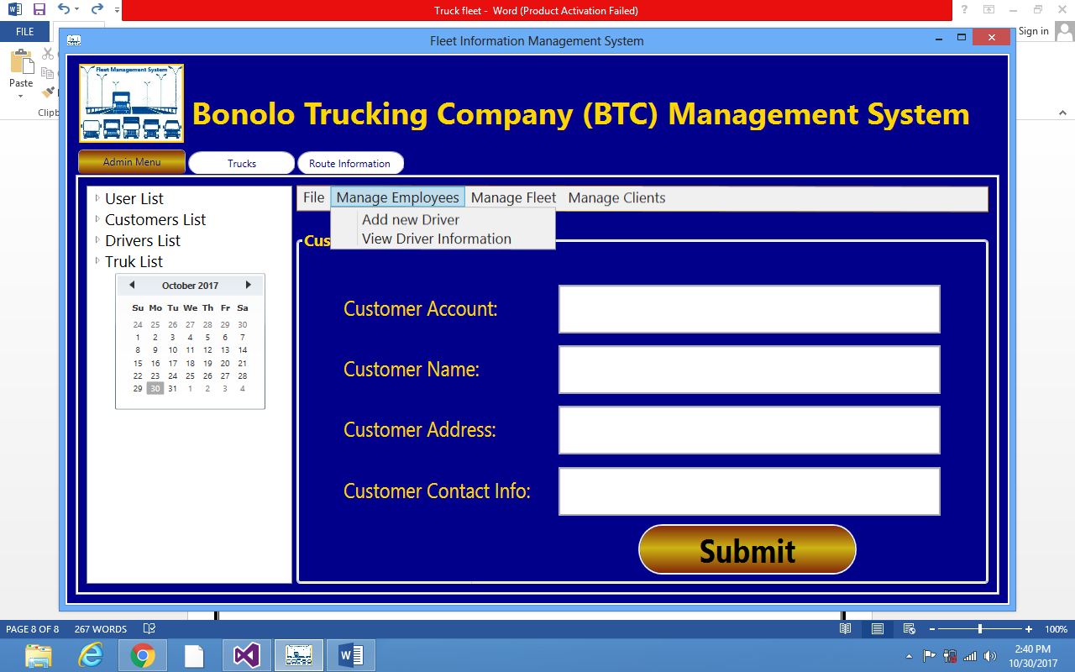

* When you click the Add driver tab the next window will appear
* On that window you will be able to add a driver

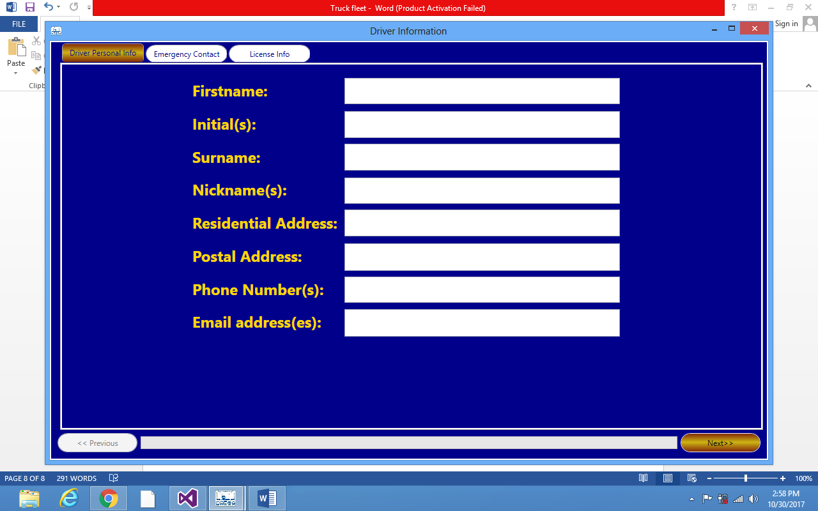

* On this very same window there is a next button when you click it the next window will appear which Is a continuation of the driver’s info that window is Emergency Contact
* When you continue click the license info tab will also appear
* And when you click the Driver’s information you will be able to see the information of the driver where you will be able to update the any information.

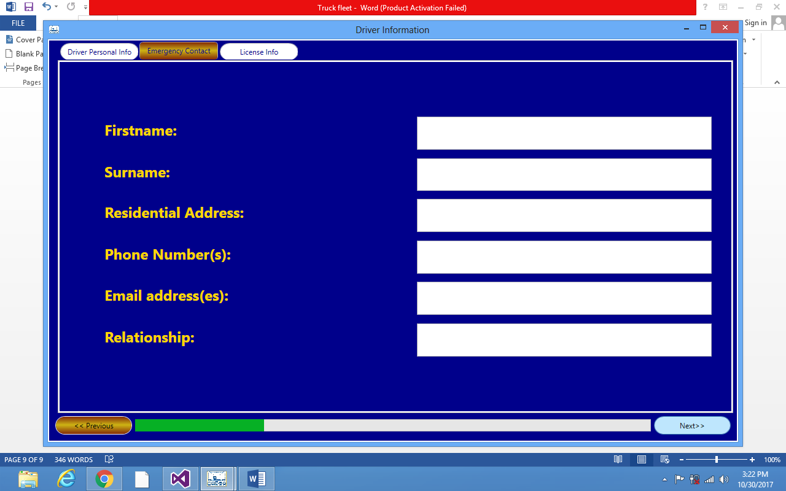

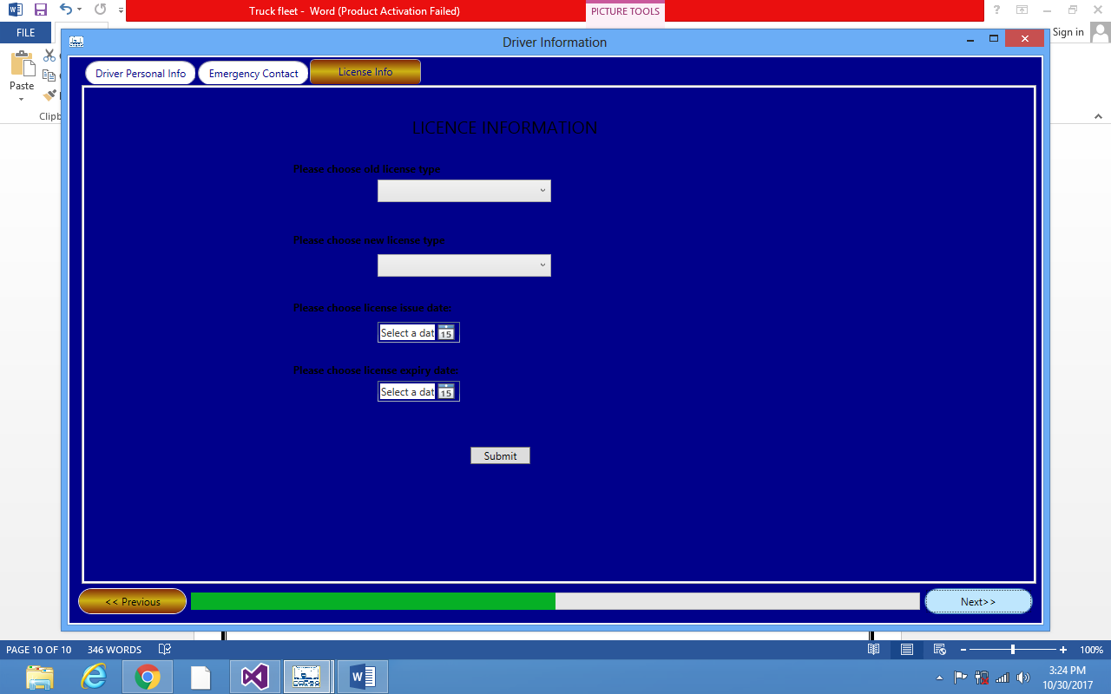

**MANAGE FLEET**

* On this window when you click the Manage fleet tab two tabs will appear which is the Add new Truck and the view Truck information tab.
* When you click the Add new Truck tab a window of add new truck details will appear, after you done entering the details click the button Submit with the red arrow pointed on it.

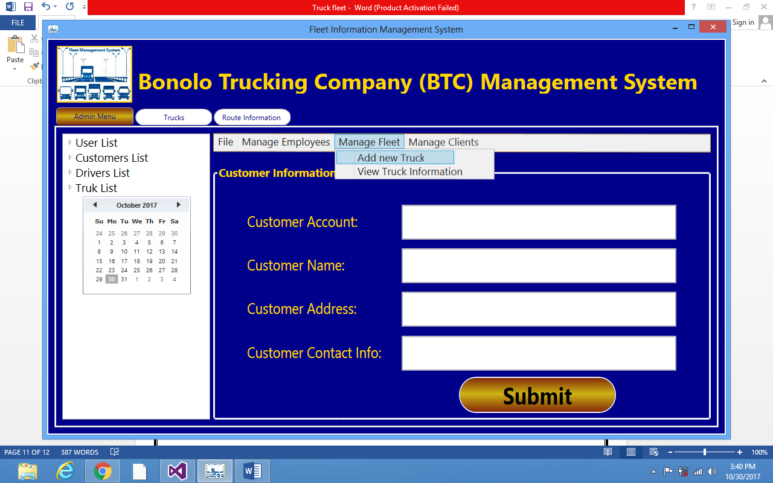

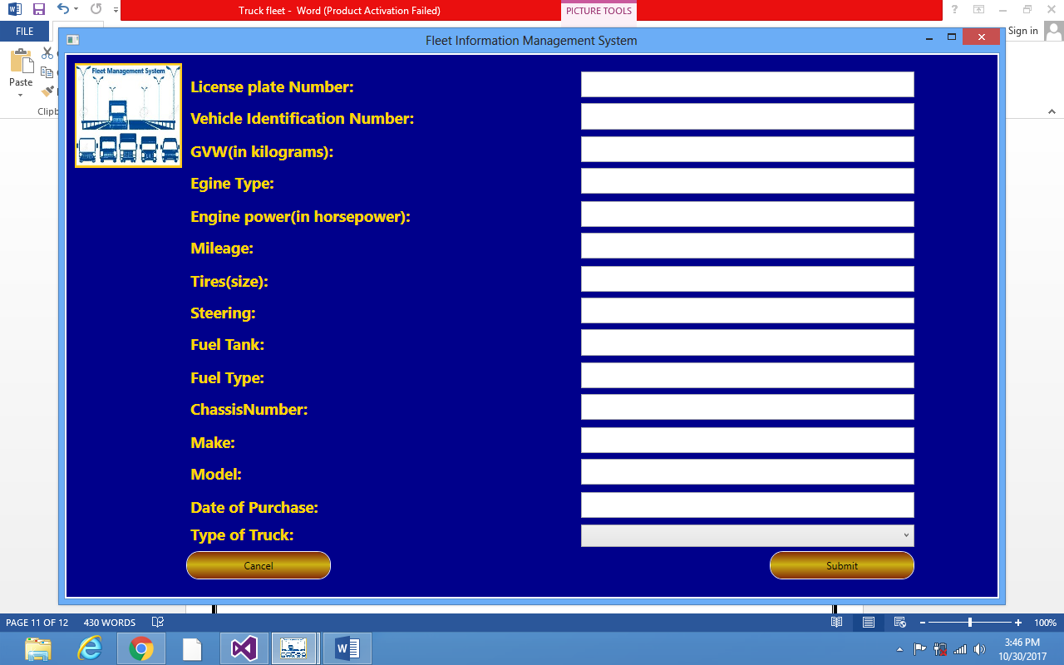

**ROUTE INFORMATION**

* On this window you are able to add route information and when you are finish you can click the button submit.
* Notice after clicking submit the same window will show your route on a map

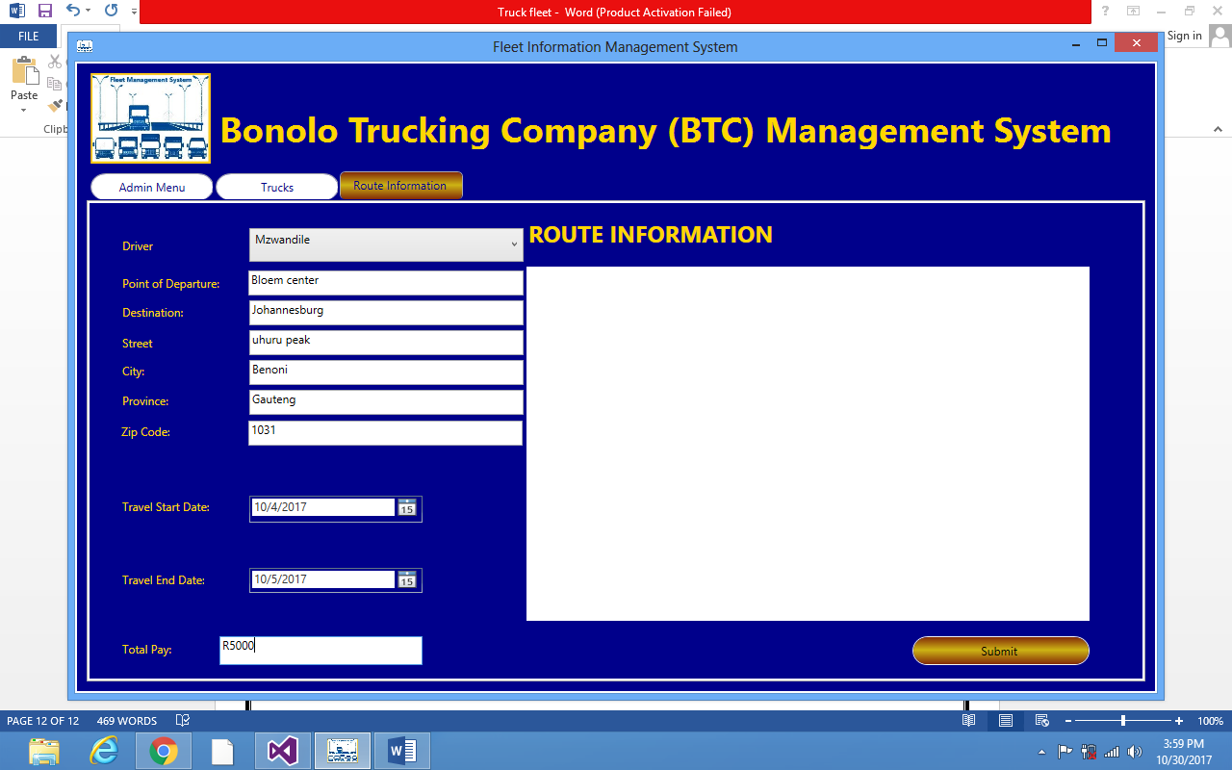

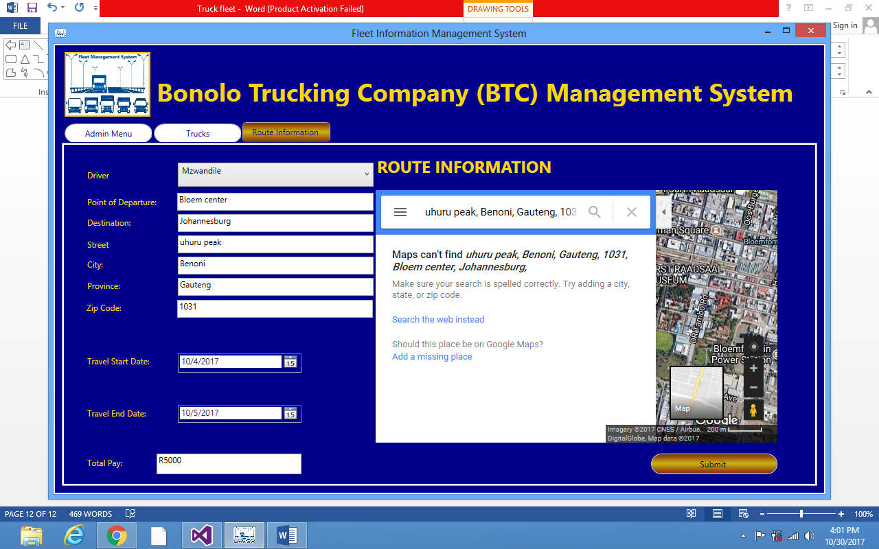

LOGGING OUT

* When you click the tab File you will see two options it’s up to you which one you click but both will lead you back to the home screen then you will be done with the process.

